Five project
The way we are
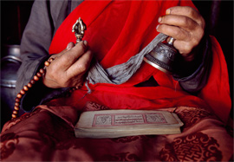
The learners will use this project to learn different cultures and to understand different people since in South Africa we speak 11 official languages.

Global warming –the planet is heating up
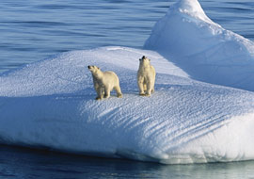
In the olden day people were not wearing anything and the earth was not so hot as it is now. My student will know what contribute to this change of climate and how people living in this earth can decrease global warming

Weather
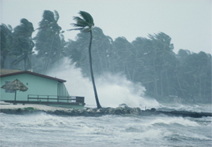
In this project student will know about what causes bad weather. In Zulu if they is no rain or too much rain the pure virgin girls go to the mountain and ask the Queen of Rain to stop the rain or to make it rain. Student will communicate through EPals on how other cultures go about if they are this condition of bad weather
Natural disaster
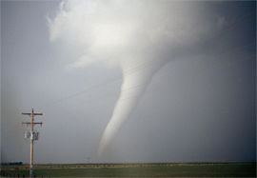
What do you do when the news warns of a big storm? In this project, students learn about the natural disasters of the world. Through email exchanges, students will learn about natural disasters, where and under what conditions they are most likely to occur, particularly those natural disasters common in their ePals' location.
Water
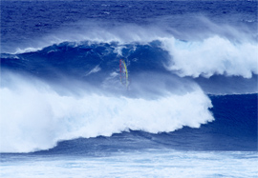
When is water good to drink? In this project, students will research the world's water problems, focusing on how their personal water use affects aquatic ecosystems in their communities. Students will participate in email exchanges, exploring the global importance of water, particularly in their ePals' location.

